Biography of Dean Carolyn Terry

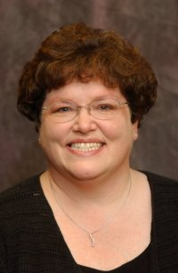
Dean Carolyn Terry joined the English Department faculty at Montgomery College in 1989, coming The Pennsylvania State University, where earned a B.A. with high distinction and honors in English and an M.A. with a concentration in composition and rhetoric theory. During her faculty appointment, Ms. Terry served in a variety of roles: as faculty coordinator of the Rockville Campus Writing and Reading Center; as department chair of English Composition, Literature, and Professional Writing; and as acting instructional dean of Humanities and Social Sciences. In 2000, she was appointed instructional dean of Humanities at the Rockville Campus. In that role, she provides academic leadership to the English, English as a Second Language, Reading, Foreign Languages, Philosophy, and Women’s Studies disciplines. Ms. Terry is the college-wide, lead dean for English, the Honors Program, Women’s Studies, and Montgomery Scholars.
Ms. Terry’s professional associations include memberships in Phi Beta Kappa, National Council of Teachers of English, Community College Humanities Association, Maryland Network of Women in Higher Education, and the Montgomery County Association for Hearing Impaired Children. She serves as a member of the planning committee for the annual F. Scott Fitzgerald Conference, a partnership between the city of Rockville and Montgomery College, and as a member of the steering committee for the partnership between Montgomery College and Montgomery County Public Schools.
Dean Terry lives in Derwood, MD, with her husband of 23 years, Jim – a program assistant in the Robert E. Parilla Performing Arts Center – and her fifteen-year-old twins, Ben and Rachel. She is currently a candidate for the doctorate in Community College Leadership at Morgan State University.

